TO: Kelly Evans, Chair, Undergraduate Affairs Council
FROM: Natalia Ruiz-Rubio, Chair, General Education Coordinating Committee
DATE: October 28, 2014
RE: General Education Curriculum Assessment 2012-2013 Summary Report

The General Education Coordinating Committee (GECC) has organized its assessment activities around three annual cycles that cover assessment of (1) university competency courses in English, Math, and Computer Sciences, (2) core subject areas in Humanities/Fine Arts, Social Sciences, and Natural Sciences, and (3) graduation requirements in Senior Capstone, International Studies, and Cultural and Gender Diversity.

In 2012-2013, GECC assessed the classes taught for the graduation requirements: Senior Capstone, International Studies, and Cultural and Gender Diversity GECC asked for course assessment either in Winter 2013 and/or Spring 2013. Also to assist in evaluating the assessment reports in a consistent manner, GECC used a tailored rubric. Members of the committee were assigned individual reports to evaluate and provide feedback on them. Then, members discussed them with the whole committee. Rubric is attached in this report.

The following objectives for the graduation requirements were selected for assessment during this cycle. GECC called for assessing Goal 1 Objective 1
CAPSTONE: Students demonstrate ability to synthesize and apply discipline-specific skills and knowledge to work-world and civic issues. Or for multiple-disciplinary capstones: Demonstrate ability to synthesize and apply skills and knowledge from multiple disciplines to work-world and civic issues.
INTERNATIONAL STUDIES: Students will have a thorough knowledge of a broad problem or topic related to the global community.
CULTURE AND GENDER DIVERSITY: Students will identify contributions of historically disadvantaged groups to modern U.S. society and culture.
Overall findings: GECC assessed a total of 33 reports. 13 assessment reports submitted were Capstone (out of 36 calls for assessment), 6 assessment reports submitted were International Studies (out of 14 calls for assessment), and 14 assessment reports submitted were Culture and Gender Diversity (out of 19 calls for assessment).
- 88% assessed the objective GECC requested, and 88% included the instrument they used to assess the objective.
- On a scale of 1 to 5 on how well the instrument assessed the objective, 66% were given a 4 or a 5, 15% were given a 3, and 14% were given a 2 or 1.
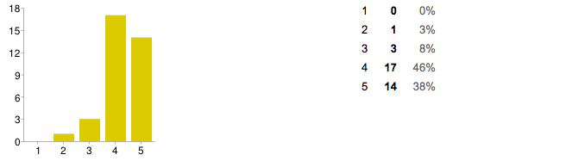

- 58% of reports summarized results quantitatively, and 15% summarized results qualitatively.
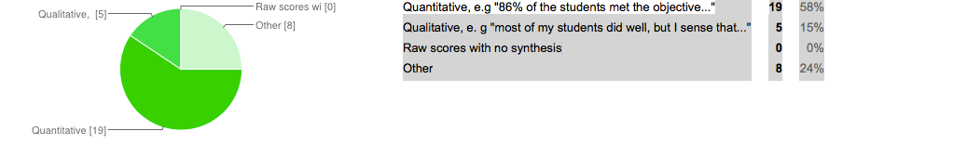
- On a scale of 1 to 5 on how well reports summarized the results, 75% of the reports were given a 4 or 5, 12% were given a 3, and 9% were given a 2 or 1.
- On a scale of 1 to 5 on how well reports interpreted the results, 60% of the reports were given a 4 or 5, 21% were given a 3, and 6% were given a 2 or 1.

- 48% reported that virtually all of their students met the objective, and another 39% said that most of the students met the objective.

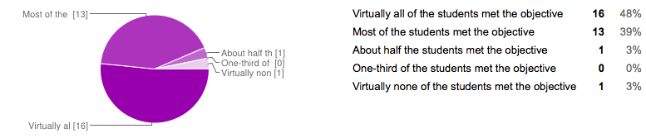
- 64% of the reports specifically discussed changes to course delivery that ought to made in light of the assessment results, and 12% did not mentioned any possible changes.

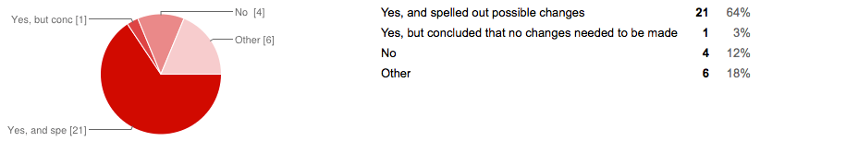

Examples of findings:

Feedback on the use of Instrument
- “The instrument used clearly required students to make connections in the class, and was an effective means of assessing how well students understand key concepts in the class”
- “The responses seemed to demonstrate that significant learning had taken place, but, like the professor, I have concerns regarding only using self-assessment to determine if the learning objectives have taken place”
- “The preparer(s) correctly understood that an instrument consisting of a survey of multiple choice questions would be not useful when administered prior to class discussions of the subject material. It is also not clear how the set of questions included correlate with the objective being assessed. They may do so, but the connection is not made very clear at all”

On the interpretation of the results
- “Well done! Summary not only provides with quantitative results, it also provides with comments on the strongest areas as well as the weakest”
- “As mentioned earlier, more discussion/interpretation of your qualitative results would be advantageous for the assessment process”
- “I would suggest providing a clear pic of the result in term on student learning”.
On the changes to improve student learning
- “The attention to students' writing skills, both to enhance content learning and writing skills themselves, is powerful”
- “Very extensive discussion about possible changes to improve student learning
- Yes, report states the importance of exposing students to major theories at an early state in the course. It also commented on the need to focus on researching with primary sources (i.e use of databases and archives).
Recommendations: The following recommendations are draw from feedback from reports, and discussion with the whole committee.
- Reports should specify goals being assessed in the course in relation with the discipline/course content.
- Training opportunities could address the use of an effective instrument and assessment design to measure student learning.
- Summaries should provide with quantitative results as well qualitative comments.

2012-13 GECR Assessment Evaluation Form‬‬
Please use the following form for each 2012-2013 Capstone/International Studies/Culture and Gender Diversity assessment report.‬‬‬‬‬
Course Number: *
Required
Is this a Capstone/International Studies/Culture and Gender Diversity course?*
Required
- Capstone
- International Studies
- Culture and Gender Diversity
Did they assess the correct Goal and Objective? GECC called for assessing Goal 1 Objective 1
CAPSTONE: Students demonstrate ability to synthesize and apply discipline-specific skills and knowledge to work-world and civic issues. Or for multiple-disciplinary capstones: Demonstrate ability to synthesize and apply skills and knowledge from multiple disciplines to work-world and civic issues. INTERNATIONAL STUDIES: Students will have a thorough knowledge of a broad problem or topic related to the global community. CULTURE AND GENDER DIVERSITY: Students will identify contributions of historically disadvantaged groups to modern U.S. society and culture.
- Yes
- No
If no, please explain
Did the report include the instrument used to assess the objective?
- Yes
- No
- Other:
How well does the instrument authentically assess the objective?
 | 1 | 2 | 3 | 4 | 5
Low |  |  |  |  |  | High
Comments about the instrument used...

How did the report summarize the results?
Quantitative, e.g "86% of the students met the objective..."
- Qualitative, e. g "most of my students did well, but I sense that..."
- Raw scores with no synthesis
- Other:
What were the results? Pick the answer that best fits the results...
- Virtually all of the students met the objective
- Most of the students met the objective
- About half the students met the objective
- One-third of the students met the objective
- Virtually none of the students met the objective
How well did the report summarize the results?
 | 1 | 2 | 3 | 4 | 5
Low |  |  |  |  |  | High
Comments about the summarized results...
How well did the report interpret the results?
 | 1 | 2 | 3 | 4 | 5
Low |  |  |  |  |  | High
Comments on the interpretation of the results...
Did the report specifically discuss any changes to improve student learning that ought to be made in light of the results?
- Yes, and spelled out possible changes
- Yes, but concluded that no changes needed to be made
- No
- Other:
Comments on the changes to improve student learning...
Comments on the assessment as a whole...
Evaluator

