Step One

Set your goal & decide what you need to develop.
What is your outcome goal? What are the skills and qualities needed to accomplish this goal?

OUTCOME GOAL: ___________________________________________________________________________

WHAT DO I NEED TO DEVELOP: ________________________________________________________________________
__________________________________________________________________________________________________
__________________________________________________________________________________________________

To achieve your outcome goal, there are some areas in your life that require immediate attention and/or improvement. These are your performance goals. Use the list you created above and create three performance goals that you can start working towards today. These are the skills, qualities or objectives that will get you closer towards your outcome goal.

PERFORMANCE GOAL ONE: ___________________________________________________________________________

PERFORMANCE GOAL TWO: ___________________________________________________________________________

PERFORMANCE GOAL THREE: __________________________________________________________________________

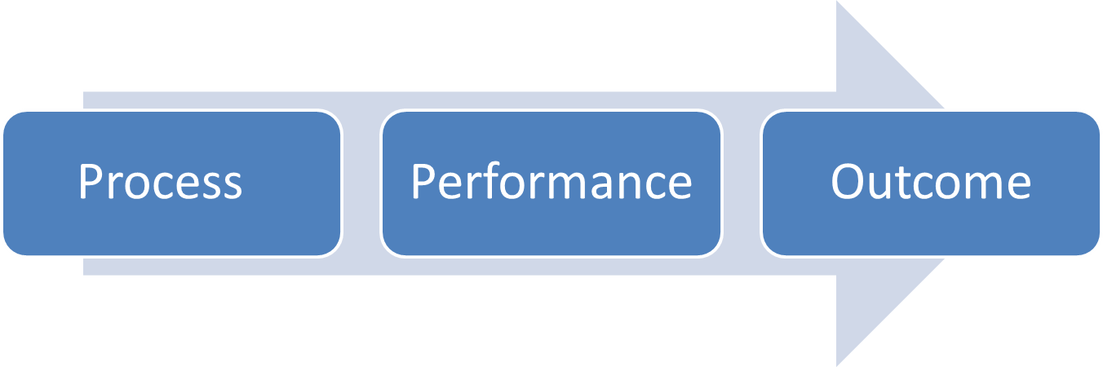
Step Two

Make a plan for steady improvement.
For each performance goal, write three process goals (to-do list). These are actions you can start as early as today. These actions will ultimately lead you towards accomplishing your performance goal.

PERFORMANCE GOAL ONE: _______________________________________ BY: ____________________

PROCESS ONE: _____________________________________________________BY:____________

PROCESS TWO: _____________________________________________________BY:____________

PROCESS THREE: _____________________________________________________BY:____________

PERFORMANCE GOAL TWO: _______________________________________ BY: ____________________

PROCESS ONE: _____________________________________________________BY:____________

PROCESS TWO: _____________________________________________________BY:____________

PROCESS THREE: _____________________________________________________BY:____________

PERFORMANCE GOAL THREE: _______________________________________ BY:____________________

PROCESS ONE: _____________________________________________________BY:____________

PROCESS TWO: _____________________________________________________BY:____________

PROCESS THREE: _____________________________________________________BY:____________

Step Three

Commit and monitor your progress.
Create a commitment strategy (post your goals where you can see them, tell a friend, use your phone, etc.). This will help you stay on track towards accomplishing your goals.

COMMITMENT STRATEGY: ____________________________________________________________________________

How will you handle setbacks, adversity and roadblocks? Identify three potential roadblocks that may interfere with your progress towards your outcome or performance goals. Then create a strategy to overcome each roadblock.

ROADBLOCK ONE: ___________________________________________________________________________________

STRATEGY ONE: _____________________________________________________________________________________

ROADBLOCK TWO: __________________________________________________________________________________

STRATEGY TWO: ____________________________________________________________________________________

ROADBLOCK THREE: _________________________________________________________________________________

STRATEGY THREE: ___________________________________________________________________________________

Step Four

Reward yourself.
It’s important to celebrate your victories (no matter how small). If you accomplish your performance goals, what will you do for yourself?

